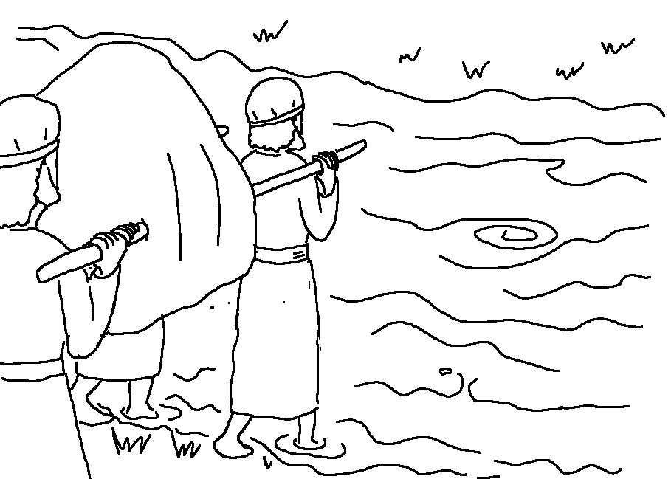
…Do not be afraid …for the Lord your God will be with you wherever you go. Joshua 1:9_{NIV}

